+++++++++ Initial Pi Setup +++++++++

1. Setting up localization settings.

a. Change the Pi localization settings to meet your requirements

Start>preferences>Raspberry Pi Configuration>Localization

reboot when finished

2. Update the Pi until the system is at the latest version

reboot when finished

3. Copy nrset folder to pi user desktop

4. Set permissions for the ST.sh files and the settings.js file to allow permissions for anyone

- right click on file properties>permissions

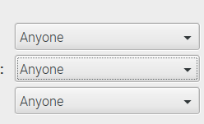

5. Set the permissions for all of the other files for anyone as well

6. Run St2.sh as from the terminal (not as sudo) and accept all the prompts.

/home/pi/desktop/SQLAMP/st1.sh

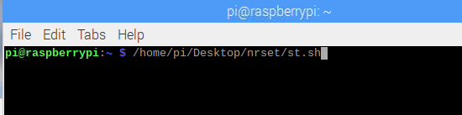

SQLAMP

Below this point, you must enter the commands manually to configure the database Server settings.

NOTE: \*\* use default Pi user and pass info to run below if asked. \*\*

sudo su

mysql -u root -p

GRANT ALL ON \*.\* TO 'nodered' @'192.168.1.%' IDENTIFIED BY 'nodered' with grant option;

Exit

Exit

7. Run St2.sh as from the terminal (not as sudo) and accept all the prompts.

/home/pi/desktop/SQLAMP/st2.sh